You want to schedule a list of jobs in d days. Jobs are dependent (i.e To work on the i-th job, you have to finish all the jobs j where 0 <= j < i).

You have to finish **at least** one task every day. The difficulty of a job schedule is the sum of difficulties of each day of the d days. The difficulty of a day is the maximum difficulty of a job done in that day.

Given an array of integers jobDifficulty and an integer d. The difficulty of the i-th job is jobDifficulty[i].

Return *the minimum difficulty* of a job schedule. If you cannot find a schedule for the jobs return **-1**.

**Example 1:**

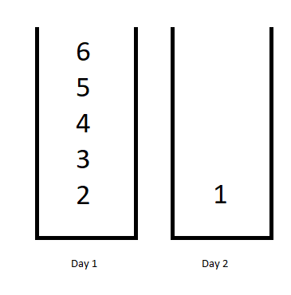

**Input:** jobDifficulty = [6,5,4,3,2,1], d = 2

**Output:** 7

**Explanation:** First day you can finish the first 5 jobs, total difficulty = 6.

Second day you can finish the last job, total difficulty = 1.

The difficulty of the schedule = 6 + 1 = 7

**Example 2:**

**Input:** jobDifficulty = [9,9,9], d = 4

**Output:** -1

**Explanation:** If you finish a job per day you will still have a free day. you cannot find a schedule for the given jobs.

**Example 3:**

**Input:** jobDifficulty = [1,1,1], d = 3

**Output:** 3

**Explanation:** The schedule is one job per day. total difficulty will be 3.

**Example 4:**

**Input:** jobDifficulty = [7,1,7,1,7,1], d = 3

**Output:** 15

**Example 5:**

**Input:** jobDifficulty = [11,111,22,222,33,333,44,444], d = 6

**Output:** 843

**Constraints:**

* 1 <= jobDifficulty.length <= 300
* 0 <= jobDifficulty[i] <= 1000
* 1 <= d <= 10